LEG submission in implementing the gender action plan

- Mandate and background

COP 28 invited Parties, United Nations entities, the UNFCCC constituted bodies, and relevant organizations, in accordance with their respective mandates and priorities, to submit via the submission portal by 31 March 2024 their inputs on progress, challenges, gaps, and priorities in implementing the gender action plan, categorized by deliverable or output for each activity under the gender action plan, and on future work to be undertaken on gender and climate change, with a view to the submissions informing the final review of the implementation of the enhanced Lima work programme on gender and its gender action plan at SBI 60.

The five priority areas of the gender plan in accordance with decisions 3/CP.23 and 5/CP.25 are capacity-building, knowledge management and communication, gender balance, participation, and women’s leadership, coherence, gender-responsive implementation and means of implementation, and monitoring and reporting.

The submission provides an overview of the mandates and activities of the LEG related to addressing gender considerations in the context of the Gender Action Plan, considering the work programme of the LEG, and in the technical guidance and support provided to the LDCs and the intergovernmental process.

- Related LEG mandates and provisions on gender

Mandate to the LEG | Decision 6/CP.16, paragraph 2(c):  Strengthening gender-related considerations and considerations regarding vulnerable communities within least developed country Parties”
Guiding principles | Decision 5/CP.17, paragraph 3: “Further agrees that enhanced action on adaptation should be undertaken in accordance with the Convention, should follow a country-driven, gender-sensitive, participatory and fully transparent approach, taking into consideration vulnerable groups, communities and ecosystems, and should be based on and guided by the best available science and, as appropriate, traditional and indigenous knowledge, and by gender-sensitive approaches, with a view to integrating adaptation into relevant social, economic and environmental policies and actions, where appropriate”  Decision 1/CP.16, paragraph 12: “Affirms that enhanced action on adaptation should be undertaken in accordance with the Convention, should follow a country-driven, gender-sensitive, participatory and fully transparent approach, taking into consideration vulnerable groups, communities and ecosystems”  Decision 27/CP.7, annex: gender equality is listed as one of the guiding principles for the preparation of National Adaptation Programmes of Action (NAPAs)

- Products and publications of the LEG related to gender

Guidelines and technical papers specifically on gender | LEG (2019). The Toolkit for a Gender-Responsive Process to Formulate and Implement National Adaptation Plans (NAPs). Available at https://unfccc.int/node/740.  LEG (2018). Considerations regarding vulnerable groups, communities and ecosystems in the context of the national adaptation plans. Available https://unfccc.int/node/740.  LEG (2015). Strengthening Gender Considerations in Adaptation Planning and Implementation in the Least Developed Countries. Available at https://unfccc.int/node/740.
Other resources containing technical guidance on gender considerations | LEG (2023). Efforts of the least developed countries in implementing adaptation projects under the national adaptation programmes of action, national adaptation plans, and related programmes through the financial mechanism of the Convention and the Paris Agreement. Available at https://unfccc.int/documents/631046.  LEG (2021). Gaps and needs related to the process to formulate and implement national adaptation plans (NAP) as mandated through decision 8/CP.24, para. 17. Available at https://unfccc.int/sites/default/files/resource/LEG-brief_NAP-gaps-and-needs-Mar2021.pdf.  LEG (2012). National Adaptation Plans. Technical guidelines for the NAP process. Available at https://unfccc.int/node/319.

- Detailed considerations in accordance with the priority areas of the gender action plan

  - Capacity-building, knowledge management and communication

Gender sensitivity is a key guiding principle for adaptation planning and implementation. From the NAPAs to NAPs, the LEG has ensured the integration of gender considerations through guidelines, technical advice, training, and other activities.

Technical guidelines for the formulation and implementation of NAPs

The Toolkit for a Gender-Responsive Process to Formulate and Implement National Adaptation Plans (NAPs), launched during COP 25, is a joint publication of the NAP Global Network, the LEG, and the Adaptation Committee. The toolkit offers countries options – based on the technical guidelines for the formulation and implementation of NAPs – for pursuing gender-responsive approaches in key areas of the process to formulate and implement NAPs. The toolkit also provides guidance on applying gender considerations in cross-cutting activities, including those related to institutional arrangements, stakeholder engagement, capacity development, finance, and information-sharing, in the process to formulate and implement NAPs.

The toolkit builds upon the mandate for the LEG on gender, its paper on Strengthening Gender Considerations in Adaptation Planning and Implementation in the Least Developed Countries; the work of the NAP Global Network on gender, including its framework for gender-responsive NAP processes; the secretariat’s technical paper on integrating gender considerations into climate change related activities under the Convention; and other relevant resources from various organizations.

Technical guidance on gender at LEG/NAP workshops

In the context of capacity building, the LEG and the NAP technical working group conduct yearly NAP writing workshops. The workshops are part of the direct country support of the LEG to LDCs in the formulation and implementation of the NAPs. They are designed to advance the finalization of the NAP and the transition towards the implementation of projects. The LEG mobilizes and engages experts from organizations and relevant organizations to support specific topics including gender.

Technical guidance on gender at NAP Expos

Furthermore, in collaboration with other bodies and partners, the LEG organizes training and promotes the exchange of experience at workshops and outreach events, such as the NAP Expo. NAP Expos provide an opportunity to support LDCs in integrating gender considerations into the formulation and implementation of NAPs. The LEG also held technical sessions on this matter at NAP Expos in 2022 and 2023. For example, the NAP Expo 2023 held a session on strengthening gender considerations in adaptation planning and implementation and noted that gender responsiveness is being increasingly incorporated in all phases of the adaptation cycle.

Table 1 below provides a list of gender-specific sessions conducted at the NAP Expos.

Year | Co-organizer | Topic
2023 | FAO | Advancing gender-responsive climate adaptation actions including in the agriculture, fisheries, and coastal zone sectors (FAO, LEG/Multi-stakeholders subgroup)
2023 | Multistakeholder subgroup | Multistakeholder engagement in NAPs
2022 | AC | Adaptation Committee (AC) – Opportunities for gender responsive adaptation planning and action through NAPs
2022 | AC, LEG, NAP Global Network | Consideration of gender responsive approaches in the formulation and implementation of National Adaption Plans (NAPs)
2022 | NAP Global Network | Building the evidence base for gender-responsive NAP processes
2017 | Malawi | Strengthening gender considerations in the formulation of NAP
2016 | NAP Technical Working Group | Addressing gender and other guiding principles of NAPs
2014 | Philippines | Gender considerations in the NAP process in the Philippines

  - Gender balance, participation, and women’s leadership

Gender composition of the LEG

The LEG is currently constituted of 17 experts, 5 of whom are women: 2 from the African States, and 3 from Annex II Parties. A female member assumed chairpersonship of the group from 2018 to 2021. The LEG is also the first constituted body under the UNFCCC to include an explicit provision in its Rules of Procedure (decision 10/CP.27, annex) to accommodate the temporary absence of LEG members from service owing to parental obligations.

Participation of women in LEG meetings and NAP Expos

The LEG encourages and promotes the participation of women experts and representatives in its events. Proactive measures are implemented to ensure gender balance in the resource persons and technical panels at all its events. The instructions for organizing NAP Expos for example contain specific guidance for organizers to ensure gender balance. The figure below provides statistics on participation in recent meetings and events of the LEG.

Figure 1: Percentage share of women participating in meetings of the Least Developed Countries Expert Group (LEG)
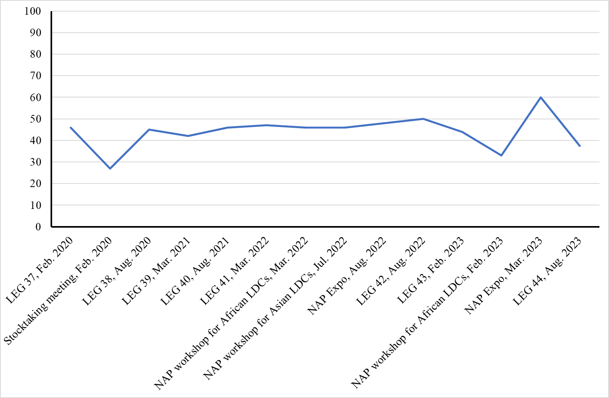

Below are highlights from some of the events:

- The 2019 NAP Expo brought together around 560 participants. Of those, 45 percent were women and 55 percent were men. It featured 12 keynote speakers, of which 7 were women and 5 were men
- The NAP Expo 2022 brought together 430 participants, 48 percent women and 52 percent men; and the event featured 15 keynote speakers, of which 6 women and 9 men, and 2 among them youth.

  - Coherence

The LEG has been working on integrating gender considerations since the commencement of its work of the LEG in 2001. The promotion of gender considerations has thereby remained an integral part of the LEG work programme in supporting the LDCs, as emphasized in the NAP Technical Guidelines. The LEG has also furthered its considerations on how to apply and expand existing gender-related technical guidelines, jointly with such partners as the AC and the NAP Global Network and developing relevant training.

  - Gender-responsive implementation and means of implementation

Technical guidance

In its current mandate, the LEG is mandated through decision 10/CP.27, para 13 to support the LDCs in integrating gender considerations into the formulation and implementation of NAPs. The process to formulate and implement NAPs, which is the main vehicle for adaptation planning and implementation, is guided using indigenous and traditional knowledge, gender sensitivity, and other important provisions.

To guarantee a gender-sensitive approach in the process to formulate and implement NAPs, the LEG has also published a paper providing views and experiences on strengthening gender consideration in adaptation planning and implementation in the LDCs. The paper draws on the experiences gained from the national adaptation programmes of action (NAPAs), and other initiatives, and presents sample tools for integrating gender into adaptation planning and implementation.

Below are highlights from the resources of the LEG on ways to ensure gender-responsive adaptation action:

- Assessing available information regarding the consideration of particularly vulnerable groups including women, boys, girls, elderly, in adaptation planning and implementation, and carry out further research on this topic in the country;
- Analysing gender gaps – such as existing inequalities in areas such as access to resources, economic participation, health, education, decision-making, etc.;
- Undertaking outreach to ensure that different stakeholders understand the gender dynamics of climate change;
- Ensuring gender balance in community engagement activities and at decision-making levels;
- Using sex-disaggregated data in vulnerability and adaptation assessments;
- Integrating the perspectives of women and drawing on their unique adaptation knowledge and local coping strategies when identifying adaptation options;
- Where possible, developing national and local guidelines to deepen assessments on gender related aspects
- Tailoring and implementing NAP activities based on gender dynamics and the disproportionate impacts on women and men, boys and girls
- Embracing women (and men) as agents of change within their communities, while undertaking the process to formulate and implement NAPs
- Empowering women to access resources.

Open NAP Initiative

The LEG has also continued to collaborate with other constituted bodies and under programmes to specifically support LDCs to address gender considerations in the formulation of their NAPs via the Open NAP initiative.

Multistakeholder forums subgroup

In the context of its 2022–2023 work programme, the LEG established four subgroups of the NAP technical working group, including one on multi-stakeholder forums to engage multiple stakeholders, including local communities, Indigenous Peoples, smallholder farmers, the private sector, women, and youth in the process to formulate and implement NAPs and advise on integrating gender considerations into the products and activities of the LEG going forward.

Roster of experts

The LEG has established an LDC Roster of Experts on NAPs, containing information on experts from LDCs with relevant skills and professional expertise in the field of climate change adaptation. 22 experts were selected (6 of them women) to be placed in the roster that will be used as a resource for countries and organizations to identify national and regional experts to engage in providing effective support to the LDCs. Those experts can promote participation and help the countries develop and implement strategies to enhance the inclusion of gender considerations in formulating and implementing NAPs.

  - Monitoring and reporting

Progress of LDCs in developing activities to strengthen gender considerations

The LEG includes in the annual progress in NAPs, information on the progress of the developing countries in addressing gender considerations in the process to formulate and implement NAPs. According to the 2023 progress report, all the 48 countries that had submitted NAPs as at 30 September 2023 highlighted the importance of gender considerations in NAPs, noting that the support of adequate policy and legal frameworks is key, as well as inter-agency coordination at all government levels, clear reporting channels, sufficient resources, and high-quality gender-disaggregated data. Furthermore, some countries stated that financial institutions have a critical role to play in requiring ministries and agencies to report gender-specific actions in NAPs, including by identifying their inclusion as a criterion for funding approval. Examples of good practices shared by countries in their NAPs include involving women’s groups at the community level in implementing gender-responsive adaptation projects; naming a gender champion in ministries responsible for adaptation actions; organizing awareness-raising sessions with men to enable them to contribute to changing negative gender dynamics; setting up a dedicated resilience fund for vulnerable women; and using gender-sensitive criteria for prioritizing adaptation options and gender-related indicators for monitoring and evaluation of adaptation actions.
Reporting on gaps and needs

Below are specific gaps and needs related to gender that have been identified through the work of the LEG in the context of the assessment of progress made in the process to formulate and implement NAPs:

- Deeper and more consistent gender consideration could be possible in the process, including: providing details on how gender considerations are being implemented; clarifying what the term ‘gender’ encompasses; adopting approaches that acknowledge that gender is not only about women but also about the relationship between women and men; and considering women as agents of change;
- The importance of attaining gender targets must be kept in mind, especially the targets and indicators of the Sustainable Development Goals.

https://www4.unfccc.int/sites/NAPC/Documents/Supplements/NAPGenderToolkit2019.pdf
https://unfccc.int/files/adaptation/application/pdf/21673_unfccc_leg_gender_low_v5.pdf
https://napglobalnetwork.org/wp-content/uploads/2017/07/napgn-en-2017-a-framework-for-gender responsive-nap-processes.pdf
FCCC/TP/2016/2.
Available at https://unfccc.int/node/748.

