Gender-responsive climate policies and implementation status in Armenia

(reporting under GAP D4; D5; D6)

The Gender Policy Implementation Strategy and Action Plan sets the government's priorities for equal participation of women in decision-making processes, achieving gender equality in science, education and socio-economic spheres, was approved by Government Decision #1334-L. on 19.09.2019.

The Council on Women’s Affairs, chaired by the Deputy Prime Minister (2019), is responsible for the implementation of the Gender Policy. The works of the Council are coordinated by the working group led by the Deputy Minister of Labor and Social Affairs. 63% of the Council members and 92% of the working group members are women, including 5 representatives of women-led non- governmental organizations.

At the same time, the importance of the gender responsive climate change policy development is in the agenda of the “Inter-Agency Coordination Council on implementation of requirements and provisions of the United Nations Framework Convention on Climate Change and the Paris Agreement”. 53% of the Council members are women, and women constitute around 80% of 3 permanent working groups adjacent the Council, which exceeded the required 30% for the female representation in working groups.
The UNDP Climate Change Programme supported number of studies and surveys on climate change gender nexus through gap and need assessment. The collected data and international experience were shared with the working groups members underlining the current status of gender issues in climate change and importance of inclusion of climate change considerations in the gender policy.
This resulted in recognition and inclusion of climate change related policies and actions in the National Strategy for Gender Equality of Armenia and its respective Action Plan for 2024-2026 (pending the government approval).
The “Developing gender-sensitive and gender-responsive approaches to climate change, ensuring inclusive principles and raising awareness “was considered as 6th priority of the national gender strategy and specific actions are outlined in the Action Plan provided below:

- Implement thematic studies of gender issues caused by climate change in the most affected sectors.
- Define gender indicators related to climate change, develop data collection methodology, and collect relevant data.
- Prepare materials for thematic courses on climate change, including gender and social impacts, and incorporate those in training programs for public servants.
- Introduce and implement a framework for encouraging women's participation in professional (vocational, training) programs and job opportunities in the fields of energy saving and alternative energy.
- Ensure the participation of women in mitigation and adaptation programs, as well as inter-agency committees related to climate change at regional and community levels.
- Develop and publicize social ads on gender and social impacts of climate change.
- Encourage the participation of women in projects aimed at adapting to climate change in the agricultural sector, particularly in agricultural insurance programs.
- Organize public awareness events on the negative impact of climate change on public health and relevant gender specificities.
The approach used in Armenia on enhancing recognition of gender specifics of the climate change impacts and corresponding gender targeted actions in the government mainstream strategies such as national gender strategy ensured efficient monitoring, reporting and evaluation framework.
Based on importance given to the above subject, for the first time, Statistical Committee of the Republic of Armenia included subsections "Environment and Gender" and "Climate Change and Gender" in the annual publication of “Men and Women”.

Managerial Positions of the
Ministry of Environment of the RA, 2023

Climate Change and Gender
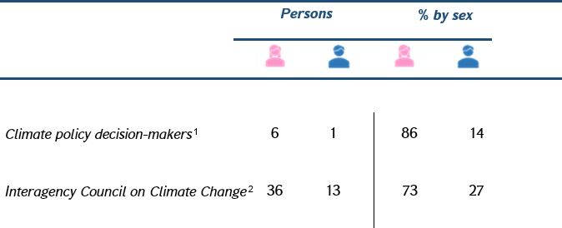

The review of the 8 climate-related sectorial strategies and polices adopted by the Government in the period of 2018-2023 revealed that gender considerations (responsiveness and sensitivity) were referred as key principles/approaches for development of corresponding actions. In particular on the strategies of Energy, Agriculture, Health, Adaptation to Climate Change the gender responsive approaches are included, however was observed that the targeted actions and monitoring indicators are lacking.
The gender vulnerability issue was specifically studied in the Water Sector Climate Risk and Vulnerability Assessment, and relevant measures were identified and included in the Water Sector Adaptation Plan, adopted by the Government Decision #1692-L from 03.11.2022.
The gender related actions of the action plan are provided below:
  - Increase women's participation in decision making and governance on national and sub-national levels,
- Increase awareness among local self-government on the water sector adaptation priorities in their community with a focus on gender approach.
- Identify vulnerable social groups and assess their specific needs on sub-national level,
- Make improved sanitation available in schools and kindergartens in communities without centralized water supply.
- Awareness raising and capacity building (including on: water-saving, drip irrigation, rain water use, disaster risk management, etc.),
- Implement water-related and agriculture-related projects on regional and community levels including trainings, introduction of new technologies and business initiatives considering gender approach.
"Climate Change and Women in Armenia “awards ceremony was organized by UNDP and RA Ministry of Environment, in cooperation with the Ministry of Labor and Social Affairs and the Council on Women’s Affairs and women-led non governmental organization “Women in Energy and Climate Change”.

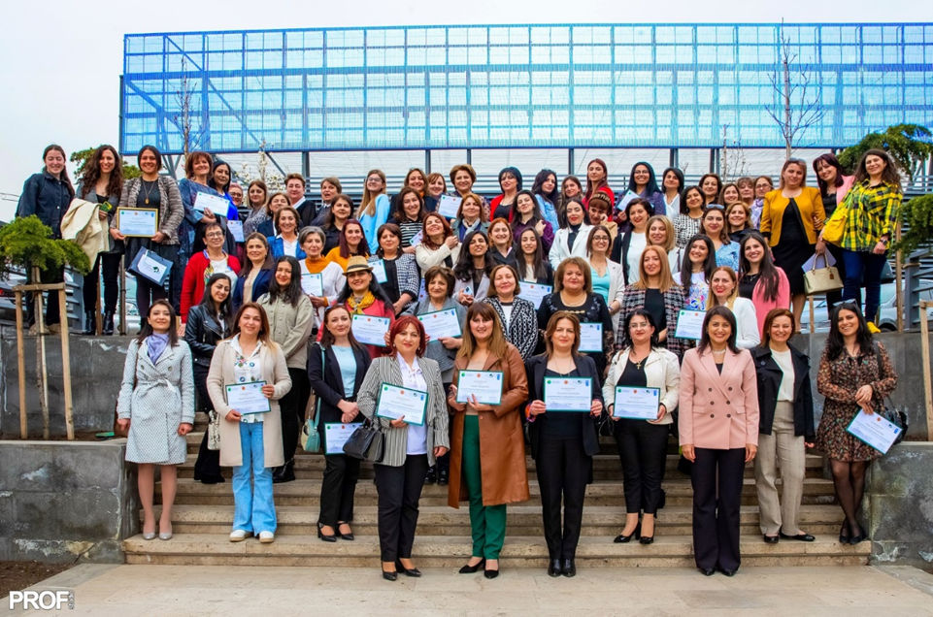

Over 100 applications were received, authors of best projects in 6 categories received awards:
The Awards Ceremony aimed at recognizing the contribution and leadership of women in climate change mitigation and adaptation processes as well as creating a platform for sharing best practices and fostering stakeholder cooperation.

Gender Aspects are reported in Armenia’s Third Biennial Update Report featured Gender Aspects of Mitigation Actions in Energy Sector, showcasing that woman can be considered as beneficiaries of "clean” energy consumption and energy efficiency, particularly in terms of reducing “time poverty”, contributing to better health and safety, as well as improving overall living conditions of the households.

Under project on Capacity Building Initiative for Transparency Armenia was developed:
- Guidance on Consideration of Gender-Related Requirements in Biennial Transparency Reports (BTR) and National Communications (NC) has been developed,
- Gender disaggregation of climate change vulnerability and adaptation monitoring and evaluation indicators are currently in process.

